# **1. Introduction**

*Provide an overview of the SDD and a description of the scope of the software.*

## Purpose

*define the purpose of this SDD and specify intended readership.*

## Scope

*identify the software products to be produced by name; explain what the proposed software will do (and not do, if necessary); describe the relevant benefits, objectives and goals as precisely as possible; and be consistent with related higher-level specifications.*

## References

*provide a complete list of all the applicable and referenced documents [SRS & any other reference used: books etc.].*

## Overview

*describe what the rest of the SDD contains and explain how the SDD is organized.*

## Constraints

*Briefly describe any restrictions, limitations or constraints that impact the design or implementation*

# **System Overview**

# **System Architecture**

## Deployment Architectural Description

## Alternative Deployment Architectural Design Description

## Design Rationale

## Component Decomposition Description

[package diagram*], A decomposition of the subsystems that summarizes the software components. Describe your reason for this packaging (consider packaging principals, coupling and cohesion, etc.). Show all the classes in each package.*

*(High cohesion within modules and low coupling between modules are often regarded as related to high quality in OO programming languages.)*

# **Technology selection**

*Provide detailed comparison of the available technology options such as programming language, database, hardware, etc. and justify your selection.*

# **Component Design**

## System Components:

“class diagram”

## Function

Sequence diagrams

## Interfaces

Data flow diagrams

## **Pseudo code and Activity Diagram.**

# **Data Design**

## Database Description [Database Design/ ER Diagram]

*Describe the persistent data structures (i.e., the Database structure), state the primary keys, foreign keys, and alternative keys, integrity rules and constraints*

## Data Dictionary

*An alphabetic list of names used by the system (entities, types, services, relations, attributes). Include a description of the named entity.*

Customers

|  |  |  |  |  |
| --- | --- | --- | --- | --- |
| **Attributes** | **Relations(PK, etc..)** | **Types** | **Services(Size)** | **Description of the attributes** |
| customerID | PK | char | 30 |  |
| name |  | varchar | 70 |  |

# **Human Interface Design** [Screen layout]

## Screen Images

*Screenshots showing (high fidelity prototype) the complete interface from the user’s perspective.*

## Report Formats

*a description of major reports provided by the system.*

# **Requirements Matrix** [traceability matrix]

*provide a cross reference that traces components and data structures to the requirements.*

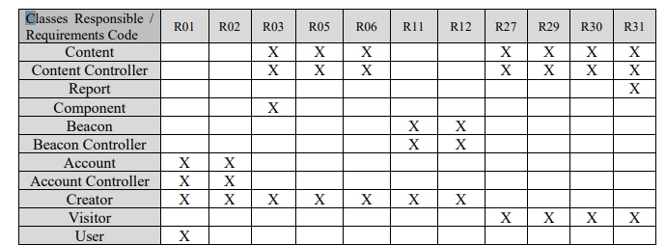

# **Resource Estimates**

*A summary of computer resource estimates required for operating the software (e.g., RAM, Storage, Bandwidth etc).*

# **Definitions**

*Acronyms, and Abbreviations - provide definitions of all terms, acronyms and abbreviations needed for the SDD.*